NetSuite Weekly Learning

Introduction to ERP (Enterprise Resource Planning)
Weekly Learning Series – Week 1

1] What is ERP?
Enterprise Resource Planning (ERP) is an integrated software system used by organizations to manage and unify their core business processes within a single platform.
It connects multiple departments such as Finance, Sales, Inventory, Procurement, Human Resources, and Operations into one centralized system that shares a common database.
Instead of using separate tools for each department, ERP ensures that all teams work with the same real-time data.

Note:
- ERP = One system managing multiple departments using a shared database.

2] Why Businesses Need ERP?
- Without ERP:
- Departments operate in silos
- Data duplication occurs across systems
- Reporting becomes inconsistent
- Manual errors increase
- Decision-making is delayed

- With ERP:
- Real-time data visibility across departments
- Standardized and automated processes
- Improved data accuracy and consistency
- Faster and better-informed decision-making
- Stronger operational control

- ERP transforms disconnected processes into a structured and efficient system.

3] Core ERP Modules:
- Most ERP systems include the following modules:
- Financial Management – Manages accounting, general ledger, accounts payable and receivable
- Order Management – Handles sales order processing and fulfilment
- Inventory Management – Tracks stock levels and warehouse operations
- Procurement – Manages purchasing processes and vendor relationships
- Customer Relationship Management (CRM) – Maintains customer data and sales tracking
- Reporting & Analytics – Provides dashboards, KPIs, and business insights

- All modules operate on a centralized database, ensuring data consistency across the organization.
- Master Data (Core Entities)
- Master Data represents the core business entities that are referenced by transactional records across the ERP system.
- Customers
- Vendors
- Items
- Chart of Accounts
- Partners
- Employees
- Locations / Warehouses

4] Cloud ERP vs Traditional ERP:
- Traditional ERP:
- Installed on company-owned servers
- Requires dedicated IT infrastructure
- Higher maintenance and upgrade costs
- Limited remote accessibility

- Cloud ERP:
- Hosted on the vendor’s infrastructure
- Subscription-based pricing model
- Accessible through a web browser
- Automatic updates and reduced maintenance effort

- Cloud ERP provides scalability, flexibility, and easier system management.

5] Why ERP Fundamentals Matter for Developers
- As an ERP developer:
  - Understanding record relationships and data models
  - Designing scalable customizations
  - Managing governance limits
  - Writing optimized scripts
  - Ensuring compliance and audit traceability

6] ERP Modules Diagram:
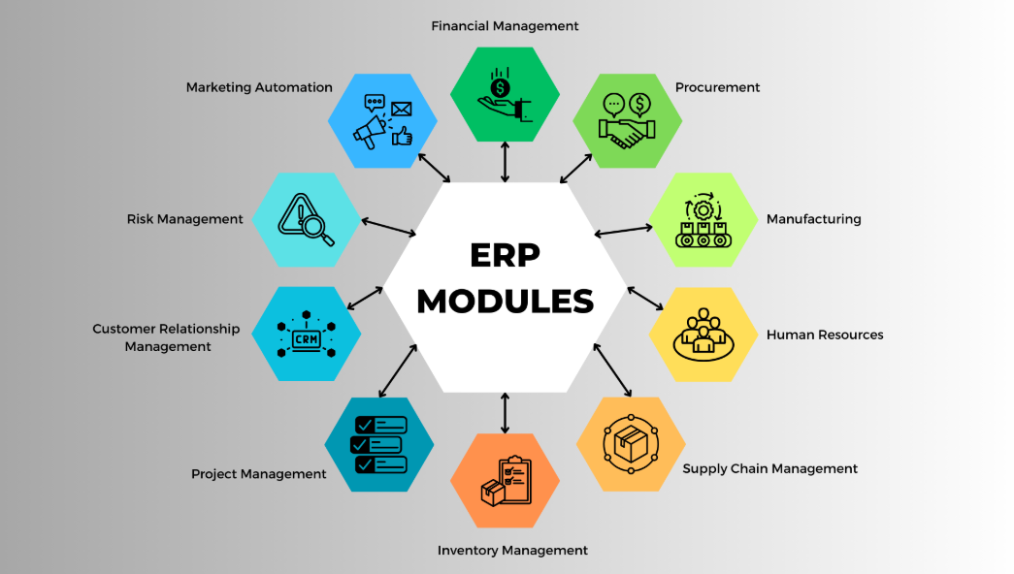

7] Real-World ERP Example
- Example:
A customer places a sales order.
  - Sales creates the order.
  - Inventory checks stock availability.
  - Procurement triggers purchase if stock is low.
  - Finance generates invoice.
  - Management sees updated revenue in dashboard.
- All departments use the same data in real time.

8] Common ERP Implementation Challenges
- Resistance to change from employees
- Poor data migration strategy
- Lack of process clarity before implementation
- Customization overload
- Inadequate user training

9] Business Impact of ERP
- Reduction in manual errors
- Faster financial closing cycles
- Improved inventory turnover
- Better demand forecasting
- Increased operational visibility

10] ERP Lifecycle
- Requirement Analysis
- Vendor Selection
- System Design & Configuration
- Data Migration
- Testing
- Go-Live
- Post-Implementation Support & Optimization

- Successful ERP implementation requires alignment between business strategy, technology, and change management.

11] Conclusion:
- ERP is not just software.
- It is a strategic business backbone that connects people, processes, and data.
- Understanding ERP fundamentals builds the foundation for advanced customization, integration, and enterprise-level solution design.

